POLLARIS – COMMUNITY-BASED DECISION-MAKING PLATFORM
UI Prototype Specifications
Course: | Introduction to Software Engineering
Project Team: | Group 05
Document Version: | Version 1.0
This document presents the user interface prototypes for the Pollaris platform. Each screen is mapped to its corresponding use-case specification, detailing its primary purpose, key interactive components, navigation flow, and core business rules.
1. Screen 1: Homepage & Dashboard (screen1.png)
Screen Name: | Homepage & Dashboard
Associated Use Case: | Explore and Search Polls
Primary Actors: | Guest, Registered User
Screen Purpose: Serves as the central landing page. It displays featured and recent community polls, provides a global search function, and gives users quick access to poll creation, category exploration, and AI-assisted insights.
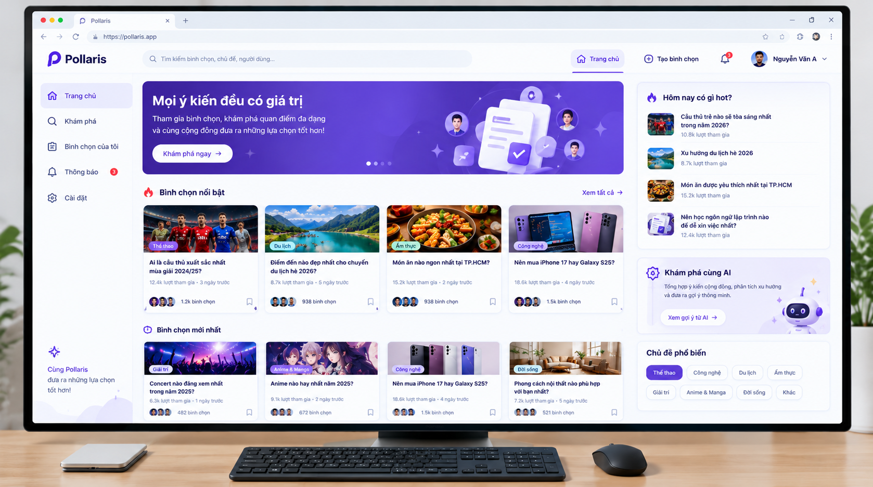
Figure 1: Homepage & Dashboard (screen1.png)
Key UI Components & Controls
Component / Region | Type | Description & Interaction
Top Navigation Bar | Global Header | Contains the Pollaris logo, search input (for polls, topics, and users), '+ Create Poll' button, notification bell icon with unread badge count, and user profile avatar.
Sidebar Navigation | Left Menu | Provides links to Homepage (active), Explore, My Polls, Notifications, and Account Settings.
Hero Banner | Interactive Carousel | Displays platform introduction with an 'Explore now' button directing users to Screen 3.
Featured Polls | 4-Column Card Grid | Presents trending polls with category badges, questions, participant counts, creation time, voter avatars, and bookmark buttons. Clicking any card opens Screen 6.
Latest Polls | 4-Column Card Grid | Displays newly published polls in reverse chronological order.
Trending Topics Widget | Right Sidebar Card | Lists top 4 high-activity polls of the day with participant counts.
AI Assistant Widget | Right Sidebar Card | Summarizes community consensus and provides a direct link to AI recommendation insights.
Popular Topics | Filter Tags | Pill buttons (Sports, Tech, Travel, Food, Lifestyle, etc.) to quickly filter polls by topic.
User Actions & Navigation Flow
• Clicking '+ Create Poll' directs authenticated users to Screen 2 (prompts guests to sign in).
• Clicking any poll card opens Screen 6 (Poll Detail & Voting).
• Clicking 'Explore' in the sidebar or banner directs to Screen 3.
• Clicking 'My Polls' directs to Screen 4; clicking 'Notifications' directs to Screen 5.
Validation & Business Rules
– Guests can freely view feeds and search; attempting to create a poll or bookmark an item requires authentication.
– Participant counts are rounded for clean display (e.g., 12.4k).
– Search input uses a 300ms debounce to prevent excessive server requests during typing.

2. Screen 2: Create a New Poll (screen2.png)
Screen Name: | Create a New Poll
Associated Use Case: | Create and Publish a Poll
Primary Actors: | Registered User (Poll Creator)
Screen Purpose: Provides a step-by-step wizard for users to create a poll. It includes input fields for questions, descriptions, and dynamic options, complemented by an AI suggestions panel that recommends questions, options, and contextual descriptions.
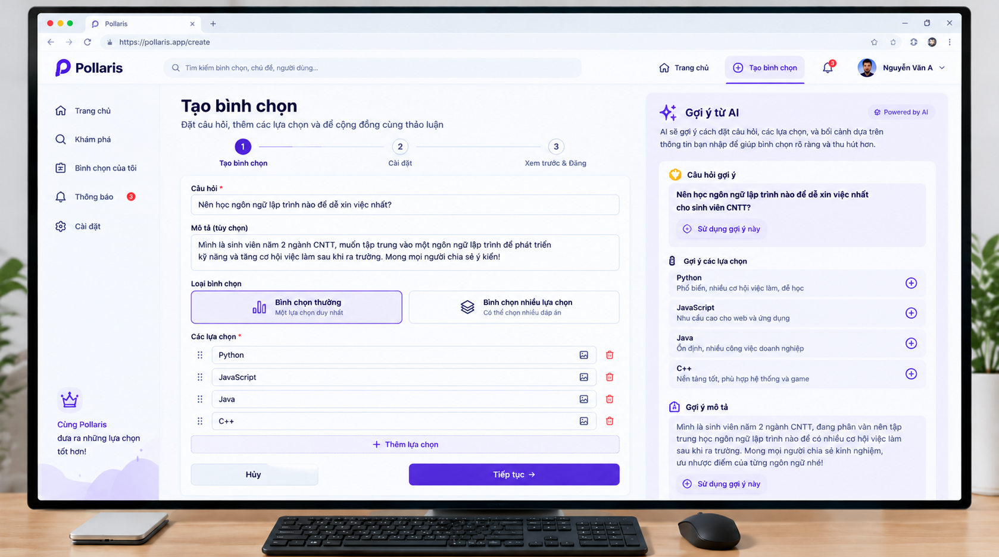
Figure 2: Create a New Poll with AI Suggestions (screen2.png)
Key UI Components & Controls
Component / Region | Type | Description & Interaction
Step Progress Bar | Stepper | Shows the 3-step creation process: 1. Create Poll (active), 2. Settings, 3. Preview & Publish.
Question Field (*) | Text Input | Required input for the main poll question (10 to 250 characters).
Description Field | Multiline Text Area | Optional field for providing background context or instructions (up to 1,000 characters).
Poll Type Selector | Radio Cards | Allows selecting between 'Single Choice' (one option only) and 'Multiple Choice'.
Options List (*) | Dynamic List | Configures 2 to 10 choices. Each row has a drag handle (::), text input, image upload button, and delete button.
Add Option Button | Outline Button | Adds an extra choice field (disabled once the 10-option limit is reached).
Form Action Buttons | Button Pair | 'Cancel' returns to Dashboard; 'Next' validates input and proceeds to Step 2.
AI Suggestions Panel | Right Sidebar | Generates context-aware recommendations: a refined question, suggested options with (+) add buttons, and a drafted description.
User Actions & Navigation Flow
• Clicking 'Cancel' returns the user to Screen 1.
• Clicking 'Next' validates required fields and moves to Step 2 (Settings: deadline, anonymity).
• Clicking 'Use this suggestion' or (+) in the AI panel auto-populates the corresponding form field.
Validation & Business Rules
– Accessible only to authenticated users.
– Validation requires a non-empty question title and at least two distinct, non-empty options.
– AI recommendations generate asynchronously without blocking user input.

3. Screen 3: Browse Categories and View AI Recommendations (screen3.png)
Screen Name: | Browse Categories and View AI Recommendations
Associated Use Case: | Browse Categories and View AI Recommendations
Primary Actors: | Guest, Registered User
Screen Purpose: Enables users to browse polls organized by subject categories and inspect AI-driven recommendations, including highlighted polls and real-time community consensus breakdowns.
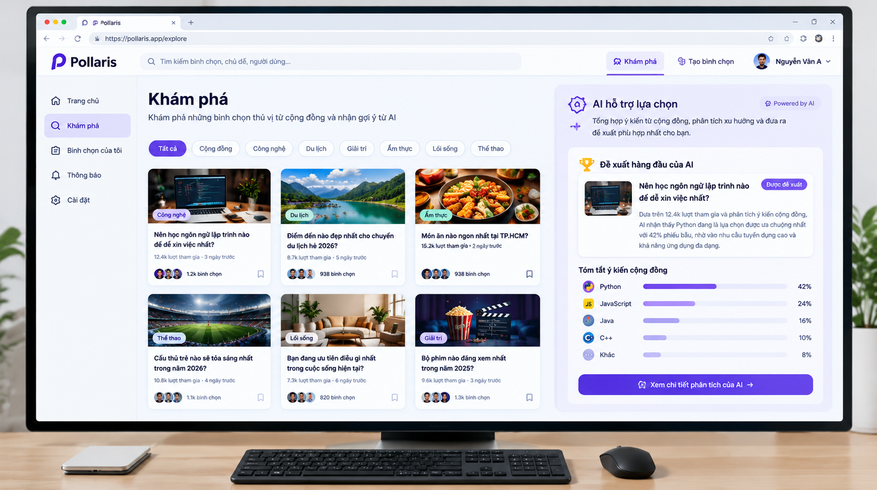
Figure 3: Browse Categories and View AI Recommendations (screen3.png)
Key UI Components & Controls
Component / Region | Type | Description & Interaction
Category Filter Tabs | Horizontal Pill Bar | Tabs include: All (active), Community, Technology, Travel, Entertainment, Food, Lifestyle, Sports. Filters content without full page reload.
Poll Grid | 3-Column Card Grid | Displays active polls matching the selected category with thumbnail, tag, question, participant count, and bookmark icon.
Top AI Recommendation | Highlighted Card | Displays the top-recommended poll selected by AI based on engagement volume and topic relevance, accompanied by a brief summary.
Community Opinion Summary | Progress Bar Chart | Visualizes percentage distribution for top choices (e.g., Python 42%, JavaScript 24%, Java 16%, C++ 10%, Other 8%).
AI Analysis CTA Button | Primary Button | 'View detailed AI analysis' opens deeper demographic and sentiment analytics for the featured poll.
User Actions & Navigation Flow
• Clicking any category pill updates the poll grid in place.
• Clicking any poll card navigates to Screen 6 (Poll Detail & Voting).
• Clicking 'View detailed AI analysis' opens the full analytical breakdown modal.
Validation & Business Rules
– When a selected category has no active polls, an empty-state message prompts users to create the first poll.
– Percentages in the consensus summary reflect live aggregated voting results.

4. Screen 4: Manage Personal Polls (screen4.png)
Screen Name: | Manage Personal Polls
Associated Use Case: | Manage Personal Polls
Primary Actors: | Registered User (Poll Creator)
Screen Purpose: Serves as the personal dashboard where creators track, monitor, and manage the polls they have published or participated in, including viewing status, voter count, and comment activity.
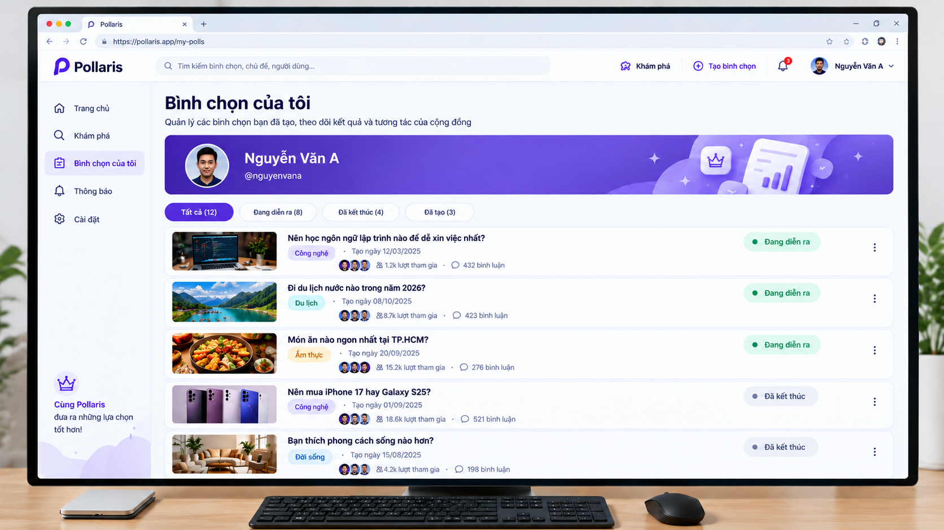
Figure 4: Manage Personal Polls (screen4.png)
Key UI Components & Controls
Component / Region | Type | Description & Interaction
User Profile Banner | Profile Header | Displays creator avatar, full name ('Nguyễn Văn A'), handle ('@nguyenvana'), and account badge.
Status Filter Tabs | Pill Group | Filters polls into: 'All (12)' (active), 'Active (8)', 'Closed (4)', and 'Created (3)'.
Poll Item Row | List Card | Each item displays thumbnail, clickable title, category badge, creation date, voter avatars, participant count, and comment count.
Status Badge | Status Indicator | Visual indicator showing '● Active' (green dot) or '● Closed' (gray dot).
Action Menu (⋮) | Dropdown Menu | Provides management options: View analytics, Edit details, Close poll early, Share link, and Delete poll.
User Actions & Navigation Flow
• Clicking any poll title navigates directly to Screen 6.
• Clicking status tabs filters the displayed list by lifecycle state.
• Selecting 'Edit' or 'Close poll' from the menu performs the corresponding administrative action.
Validation & Business Rules
– Only the authenticated owner can access management actions on their polls.
– Option text cannot be modified once voting has begun to preserve data validity; creators can only edit descriptions, thumbnails, or close the poll.

5. Screen 5: View and Manage Notifications (screen5.png)
Screen Name: | View and Manage Notifications
Associated Use Case: | View and Manage Notifications
Primary Actors: | Registered User
Screen Purpose: Provides a unified, chronological feed of interactions and platform alerts, such as new comments, votes on created polls, followers, and system completion notices.
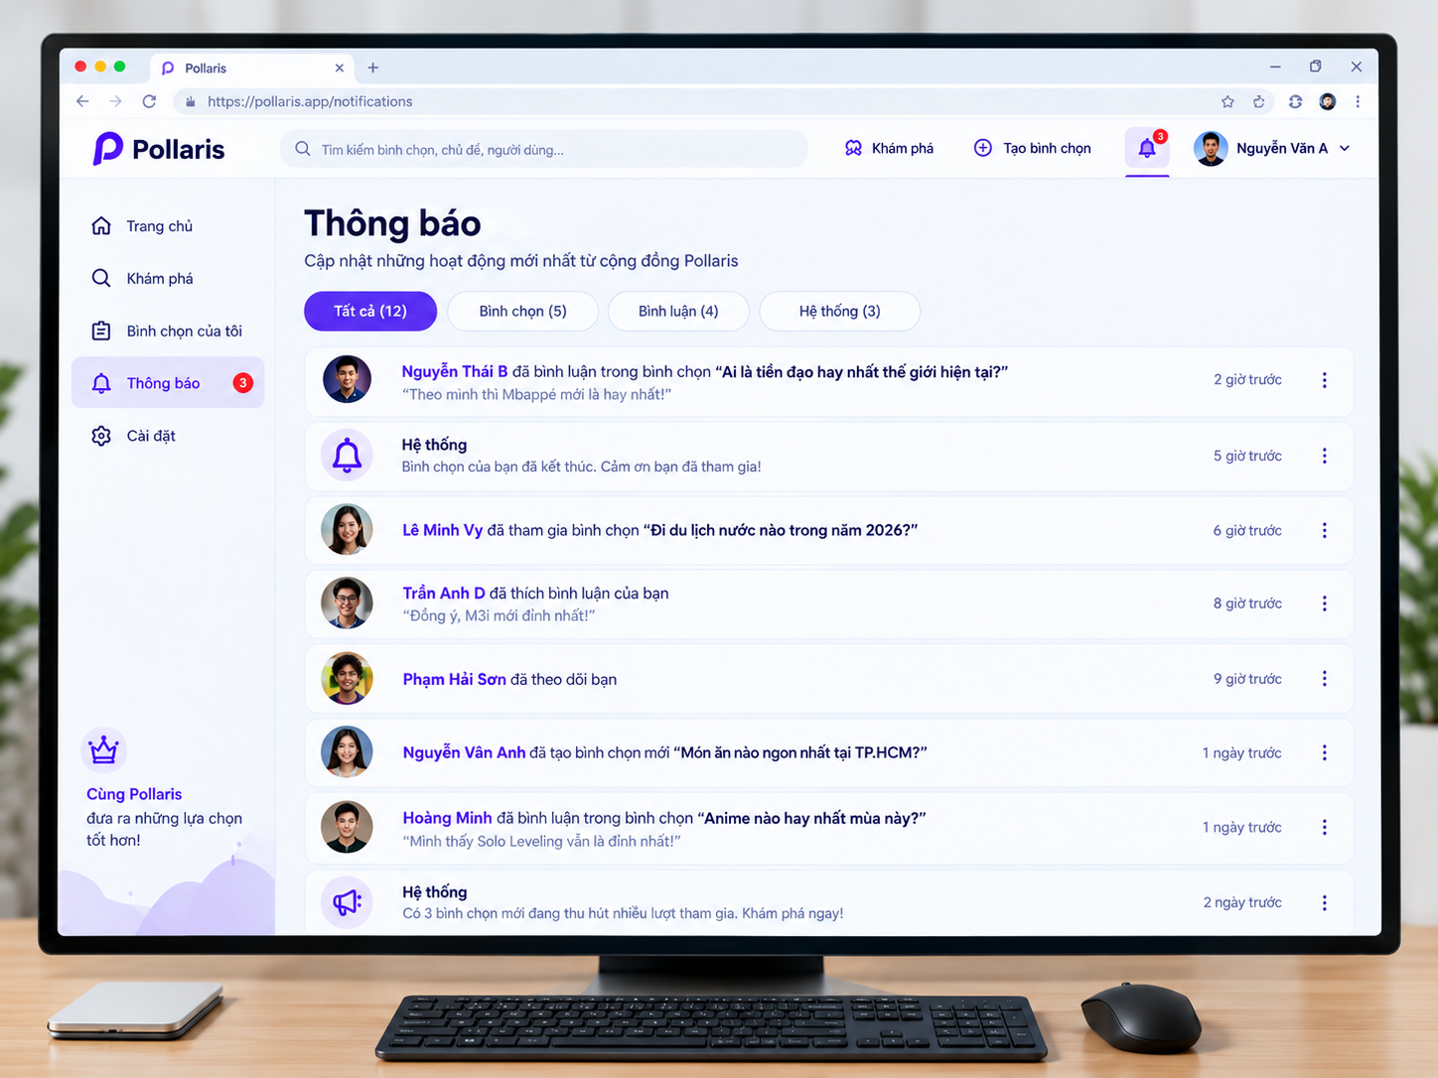
Figure 5: View and Manage Notifications (screen5.png)
Key UI Components & Controls
Component / Region | Type | Description & Interaction
Category Tabs | Pill Filter Group | Filters notifications into: 'All (12)' (active), 'Polls (5)', 'Comments (4)', and 'System (3)'.
Comment Notification Item | Feed Row | Shows user avatar, username in bold, comment action text, target poll title in quotes, excerpt, and relative timestamp ('2 hours ago').
System Alert Item | Feed Row | Shows system bell icon, notification text ('Your poll has closed'), and relative timestamp ('5 hours ago').
Social Interaction Item | Feed Row | Displays alerts for new votes, likes on comments, and new followers ('Phạm Hải Sơn followed you').
Overflow Menu (⋮) | Context Menu | Options to mark as read/unread, delete notification, or mute updates from the thread.
User Actions & Navigation Flow
• Clicking any notification item marks it as read and redirects the user to the relevant poll or comment on Screen 6.
• Clicking category tabs filters the notification list.
• System broadcast links ('Discover now') redirect to Screen 3.
Validation & Business Rules
– Marking an unread notification decrements the badge counter in the top header and sidebar.
– Timestamps use dynamic relative formats (e.g., 'just now', '5 mins ago', '2 hours ago').

6. Screen 6: Participate in Voting and View Live Results (screen6.png)
Screen Name: | Participate in Voting and View Live Results
Associated Use Case: | Participate in Voting and View Live Results
Primary Actors: | Guest (View only), Registered User (Vote & Interact)
Screen Purpose: The core interaction screen where users cast votes and view live tabulated results. An AI assistant panel on the right provides an executive summary of results, qualitative insights on trends, and suggested follow-up poll questions.
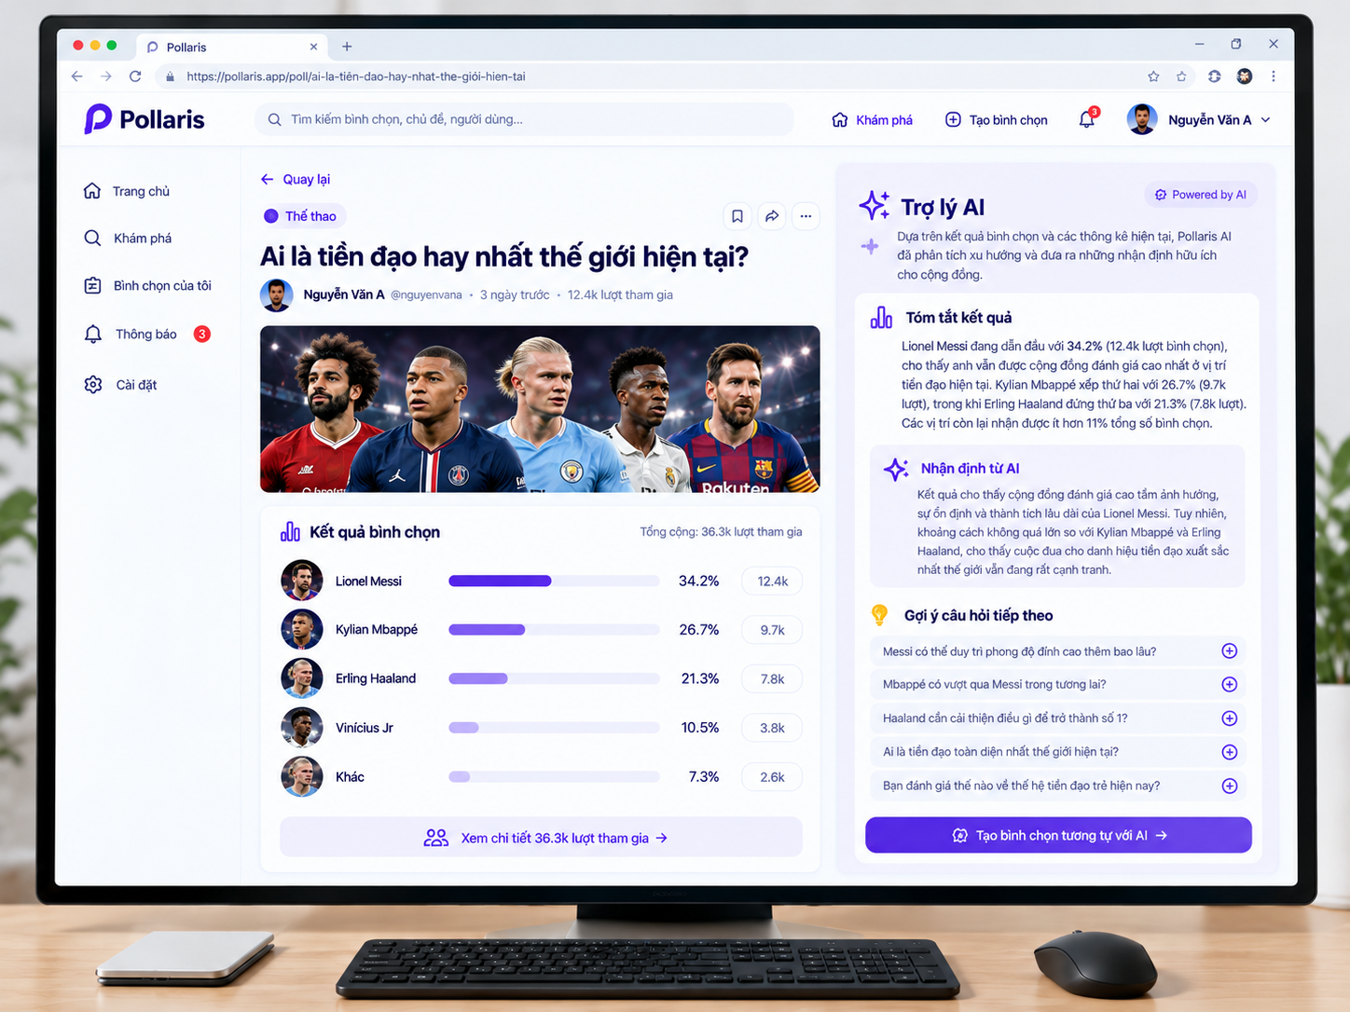
Figure 6: Participate in Voting and View Live Results (screen6.png)
Key UI Components & Controls
Component / Region | Type | Description & Interaction
Back Button | Navigation Link | 'Back' button returns to the previous browsing page.
Poll Header & Metadata | Content Header | Displays category tag ('Sports'), bookmark/share buttons, question headline, creator details, timestamp, and participant count.
Hero Visual Banner | Cover Image | Theme image representing the subject (e.g., player candidates).
Live Results Display | Tabulated Bar Chart | Shows 36.3k total votes and percentage breakdown: Lionel Messi (34.2%), Kylian Mbappé (26.7%), Erling Haaland (21.3%), Vinícius Jr (10.5%), Other (7.3%).
Participant Details Link | Text Button | 'View 36.3k participants details' opens a modal with voter demographics and public voter list.
AI Result Summary | AI Text Box | Auto-generated natural language synopsis summarizing leading candidates and margin sizes.
AI Qualitative Insight | AI Text Box | Analytical commentary interpreting voting trends and community debate factors.
Suggested Questions List | AI Interactive List | 5 related follow-up questions generated by AI, each with a (+) button to instantly create a new poll.
Create Similar Poll CTA | Primary Button | 'Create similar poll with AI' initiates poll creation with pre-filled context.
User Actions & Navigation Flow
• Clicking 'Back' returns to Screen 1 or Screen 3.
• Clicking (+) next to any suggested question opens Screen 2 with that question pre-filled.
• Clicking author name/avatar opens the author's public profile.
Validation & Business Rules
– Duplicate vote prevention: Registered users may submit only one vote per single-choice poll; after voting, options are locked to display percentages.
– Guests can inspect results and AI analysis; clicking an option prompts user authentication.
– AI summary text updates periodically as new votes are cast.

